READ AND CHOOSE THE BEST ANSWER ACCORDING TO THE TEXT:

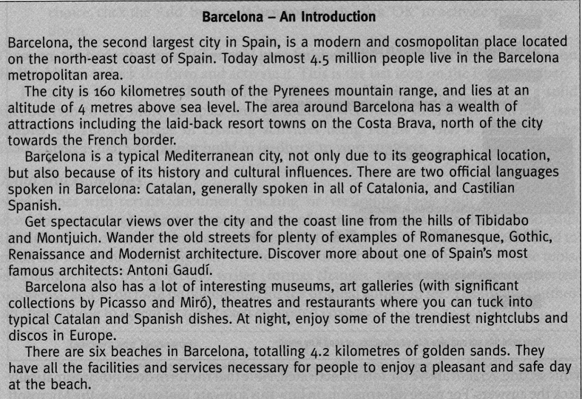Haga clic aquí para escribir texto.
Name:
Date: | 13/07/2011
1.Where in Spain is Barcelona? | In the south-west☐ In the north-east ☒ In the south-east☐
2.Which mountain range is nearest to Barcelona? | Pyreenes
3.How many people live in the city ? | 5.5 million
4.What are the most common languages spoken in Barcelona? | ☒ English-French Castilian ☐ Catalan-Spanish ☒
5.Name of famous Architec? | Picasso ☐ Antonio Gaudi ☒ Miro☐
6.How many beaches are there in Barcelona? | Six ☒ Four ☐ Three☐
7.How long are the beaches,in total?  Choose one… | 3.2 Kms ☐ 5.2 Kms ☐ 4.2 Kms☒

